
Apply for your child’s school place online at eadmissions.org.uk

Applying online for a school place is quick and easy. Follow the steps in this leaflet and you are ready to start your child’s online application.
- Each screen will explain what you need to do; more information is available wherever you see this icon, just click on it.
- A video is available on the website to watch:
  - Creating a new account
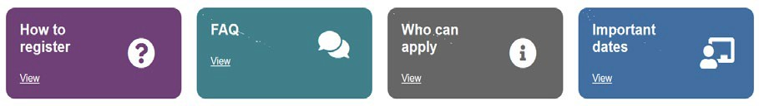

- All sections with a need to be completed.
gives guidance on the following:
gives information on the following:

- When you first use the website you can download it as an app to the device you are using. Just follow the instructions.
- Make sure you only open one browser!
Step 1: Getting started
- Before you start your online application, you will need to do some research.
- Visit your local authority’s website for details about how applications are processed.
- Find schools in your area by using the Map.
- Read the admissions criteria for the schools you are interested in.
- Visit schools.
- Check how places were offered in previous years.
- You should check transport policies for local authorities (outside London).


Step 2: What to do if this is the first time you are applying online using eAdmissions

If you have used the eAdmissions system in the last 3 years to apply for a school place for any of your children you do not need to register again. Instead please go to Step 3.
- If you used the eAdmissions website over 3 years ago you may need to register to apply online.
- If this is the first time you are using the eAdmissions website you must register to apply online.
- You will need an email address to register.
- If you already have an email address you should set your spam/junk mail filter to ‘Standard’ so that emails from eAdmissions go straight to your inbox. You should check your spam/junk email folder now and then to make sure that messages from the eAdmissions website are not sent there by mistake.
- Register yourself on the eAdmissions website.
- Your username will be displayed on screen, make a note of it.
- You will then be asked to create your own

password.
- Login to the eAdmissions website using the username and password that you have just created.
- You will be sent a validation email containing your username and instructions on how to validate your email address.
- The email will also contain a link which will take you to the eAdmissions login page to start your application.
- Please keep your username and password safe as you will need them to login and apply for any other children you have, and to see the outcome of your application. (It will be March for Secondary & 14/19 applications and April for Reception and Junior applications)
- You can opt to receive push notifications during the admissions process from an android phone or if you have an Apple device.
- It is important that you register well before the deadline in case there are any problems making your application. The closing dates are:

31 October for Secondary & 14/19 applications
  - 15 January for Reception and Junior applications


Step 3: What to do if you have applied before using eAdmissions or you have just registered and received your username
- On the home page select ‘Existing Account’ and enter your username and password.
- If you have forgotten your username we can re- send it to you, just select the ‘Forgotten your user name or password?’ link and follow the instructions on screen.
- If you have forgotten your password we can reset it and send it to you, just select the ‘Forgotten your user name or password?’ link and follow the instructions on screen.
.
Step 4: Adding your child’s details
- The next page is your home page called 'Your home page’ Click 'Start application' button.
- Enter the details requested about the child you are making the application for on the 'Child details' page and select the ‘Save and continue' button.

Please remember
Council tax account number: Some local authorities will ask you to provide this information for the address where your child lives. For more information use the icon.
Child’s current school: Please select the school from the drop-down list. Only type the name of the school in the box if your child is at a nursery school or you cannot see the current school name listed.

- Twins or triplets: If you have twins or triplets you must make an application for each child and tick the multiple birth box.
Step 5: Adding school preferences
- Add your preferences in the order you prefer them. You can select up to six schools (if you live in Surrey you can only select four preferences for Reception. Preferences for junior applications will vary, so please check with your Local Authority).
- Make sure you include the details of any brothers or sisters who will be attending one of the schools or linked schools you have applied for. If you do not tell us you may lose out on a place allocated under the sibling criterion.
- Please be aware that not all schools have a medical or social criterion, please check before selecting your schools.
- If the schools you have selected allow medical or social criteria and you would like your child to be considered under this criterion you must tick the relevant box and attach supporting evidence. You can attach documents once you have submitted your application.
Important information

If you do not provide evidence to support your application, your request cannot be considered under that criterion.
- Some schools ask you to fill in extra forms called supplementary information forms (SIF). If you do not fill in these forms and/or send them direct to the relevant school, you risk your chance of getting a place at these schools.
- It is your responsibility to check that your online application is fully completed and that you have entered all details correctly. If you do not tick certain boxes or enter relevant information (for example sibling box) your application will not be considered under that criterion.
- When a sibling is added to an application it will be displayed on your application on your home page against the preference.
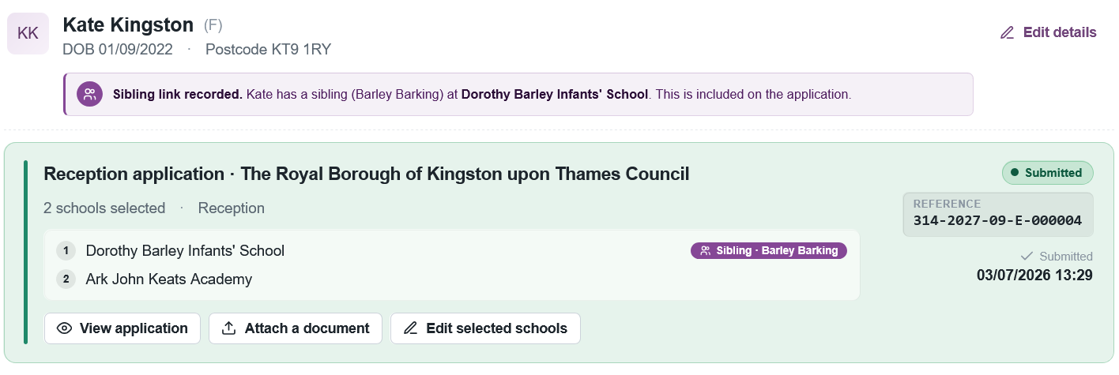

- Each time you fill in the information on a page, make sure that you select ‘Continue’. Select

to add further schools to your application. When you have finished adding
schools to your application then
Step 6: Submitting your application
- Select the ‘Submit application’ button on the last page.
- After you have submitted your application, you will receive an email confirming details of your online application. The email will list an application reference number similar to this:123-2027-09-E-123456.
If you do not receive a number it means your application was not submitted successfully and you must login and select the ‘Submit application’ button again.

Editing/changing your application
- You can edit and make changes to your online application until the closing date, but for your most recent changes to be recorded you will need to
 your application.
- Always keep your details and your childs details up to date on the website. You can do this on ‘Your home page’.
Step 7: Attaching supporting evidence
Many local authorities need you to send them evidence to support your application. You can find out what each local authority needs by reading their information booklet about applying for school places or
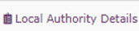
the section, for example:
- Confirmation of your child’s address and their date of birth.
- Evidence to support your application such as doctor’s letters if you have applied under the medical criterion.
- Evidence to confirm your child was looked after or previously looked after.
- Evidence to confirm that you are a crown servant. If you have ticked any of the categories above and do not provide evidence to show this, your local authority is unlikely to take this into account when making allocations.
What happens next?
- If you submitted your application by the closing date you will be sent the outcome of your application during the evening of the published national offer day.
- You should respond within 14 days. There are 2 ways to do this:
- Use the reply button in the email that you will receive during the evening. It will take you to the eAdmissions website, log in and respond.
- Return to eadmissions.org.uk, log in and select view outcome and respond.
- Some local authorities do not send letters if you have applied online. Check your local authority’s details on the left-hand side of the ‘My school admissions’ page.

Receipt details
Use the space below to record your application reference number, you may need to refer to this later.
Application Reference Number:

